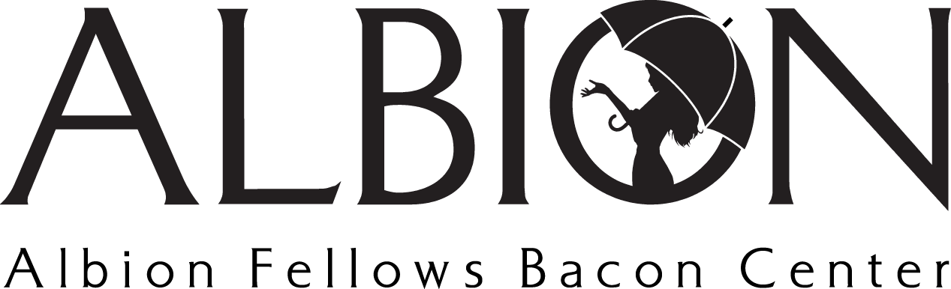
Position Title: Uplifting Volunteer
Position Type: Volunteer

Volunteer Summary: Individuals well suited for this volunteer opportunity are passionate about uplifting others. This opportunity works with Albion’s clients to enrich their lives via planned classes to provide joy (cooking, painting, etc) or skills (computer skills, ASL communication, resume classes, etc). To volunteer in this capacity, we ask that you connect with laurenb@albioncenter.org.

Position Summary: Uplifting Volunteers provide skills and knowledge to ensure that Albion’s clients can feel uplifted and empowered. You may provide enrichment via cooking classes, painting sessions, and more, or through skills classes that include resume building, language based classes, computer based classes, and more.

Main Duties
- Host classes with Albion’s clients to enrich their lives and provide joy or additional skills
- Enrich lives by providing cooking, painting, or additional classes that can help individuals define hobbies and find peaceful moments
- Enrich lives by providing skills based classes that include communication based classes, resume building, computer skills classes, and more

