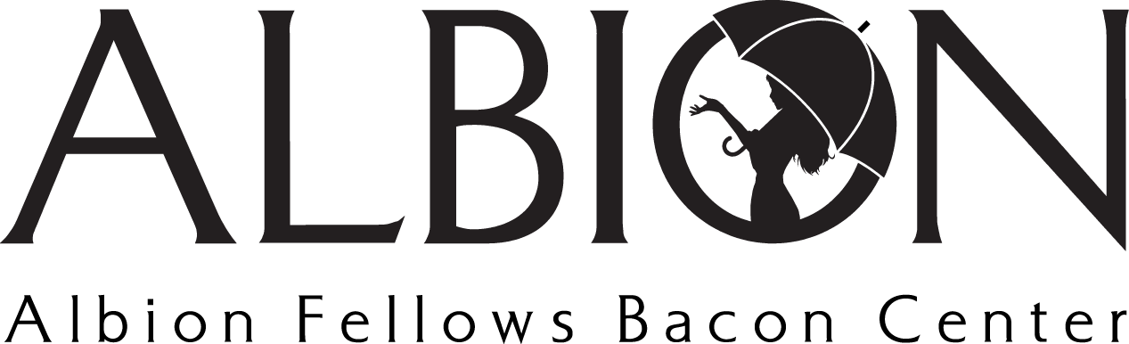
Position Title: Special Events Volunteer
Position Type: Volunteer

Volunteer Summary: Individuals well suited for this volunteer opportunity are passionate about representing Albion Fellows Bacon Center at events or serving on event planning committees. Volunteers must apply with laurenb@albioncenter.org and consent to a criminal background check.

Position Summary: As a Special Event Volunteer, you may be asked to represent Albion and provide assistance with opportunities like our Fall Festival Booth. If you are interested in serving on a special event committee, you will be put into contact with the Community Engagement Director who can then provide you with more information.

Main Duties
- Represent Albion Fellows Bacon Center and provide assistance at events like Fall Festival, An Evening of Hope, and more.
- Maintain a knowledge of domestic & sexual violence issues
- Understand and effectively communicate the services provided by Albion
- Uplift the mission & vision of Albion, connecting individuals with the agency (volunteer or clients)

Special Event Committees
- Commit to attending meetings pertaining to the event planning and execution
- Assist in the planning and implementation of the event
- Possess effective communication skills and maintain contact with the event group to ensure deadlines are met and plans are effectively in place
- Solicit gift card and gift basket donations for Albion’s An Evening of Hope

