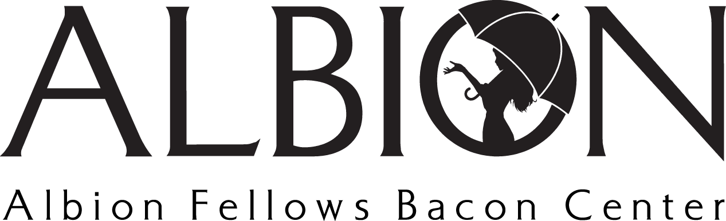
Position Title: Primary Prevention Volunteer
Position Type: Volunteer

Volunteer Summary: Individuals well suited for this volunteer opportunity are passionate about ensuring our youth are set up for success! This role supports Albion’s Primary Prevention Director and ensures classes/presentations (like Albion’s Safe Dates) help define and inspire healthy relationships and prevent the cycle of abuse! To volunteer in this capacity, we ask that you connect with laurenb@albioncenter.org.

Position Summary: As the Primary Prevention Volunteer, you ensure that area youth and community members have information related to healthy relationships and domestic/sexual violence. This may include assisting in data entry, providing support in the classroom, or additional assistance needed by the Director.

Main Duties
- Work with the Primary Prevention Team and ensure that data is captured and stored in effective ways, community events are planned and executed appropriately, and classroom support is provided when necessary
- Volunteer during community hosted events like Albion’s CAPs Poverty Simulation
- Process data from classrooms, inputing it into spreadsheets and ensuring that it is saved for later
- Assist the Primary Prevention Director where help is needed

