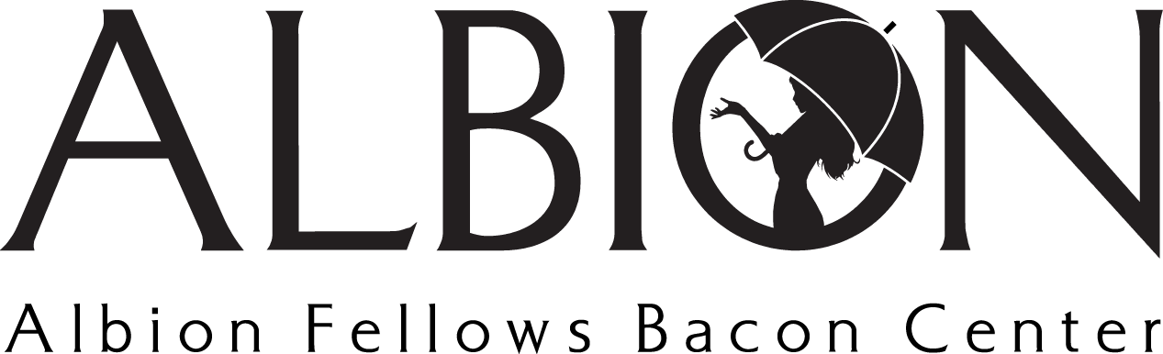
Position Title: Awareness Volunteer
Position Type: Volunteer

Volunteer Summary: Individuals well suited for this volunteer opportunity are passionate about utilizing their voice to provide support! This opportunity holds several opportunities that you may serve in. To volunteer in this capacity, we ask that you connect with laurenb@albioncenter.org.

Position Summary: Awareness Volunteers may participate in several key capacities crucial to Albion’s continued success. Individuals may choose to distribute informational materials, plan and/or present information in community based settings, and attend health fairs to represent Albion.

Main Duties
- Distribute informational materials and brochures to organizations and businesses when needed
- Assist in the creation of presentations (powerpoint skills needed) at the guidance of Albion’s Non-Residential team
- Attend informational sessions with local organizations and present on topics related to sexual and domestic violence
- Represent Albion at community events and health fairs, ensuring individuals have relevant information and are connected to our organization
- Provide support in other opportunties that may arrise

Qualified Candidates
- Are willing to maintain knowledge of current domestic & sexual violence information, including statistics and language
- Are capable of presenting to large groups
- Are passionate about raising awareness and comfortable answering questions

